Software Requirements Specification Template

Bright Light

Software Requirements Specification

V1.0.0

May 11, 2023

Team Members:
Ramadevi Redrouthu
Adi Lakshmi Meesala
Naveen Kumar Maddipati
Vineetha Ravuri
Vinesh Reddy Palla
Akhila Mitta

Submitted in partial fulfilment.
Of the requirements of
CSIS 44-691 Graduate Directed Project 1

Revision History

Date | Description | Author | Comments
<date> | <Version 1> | <Your Name> | <First Revision>
05-11-2023 | Requirements Specification | Ramadevi Redrouthu
05-11-2023 | Functional Requirements | Adi Lakshmi Meesala
05-11-2023 | Hardware Requirements | Naveen kumar Maddipati
05-11-2023 | Software Requirements | Vineetha Ravuri
05-11-2023 | Non-Functional Requirements | Vinesh Reddy Palla
05-11-2023 | Revision of Requirements | Akhila Mitta

Document Approval

The following Software Requirements Specification has been accepted and approved by the following:
Signature | Printed Name | Title | Date
Ramadevi R | Ramadevi Redrouthu | Organizer module | 05-11-2023
Adi Lakshmi M | Adi Lakshmi Meesala | User Module | 05-11-2023
Naveen Kumar M | Naveen kumar Maddipati | User Module | 05-11-2023
Vineetha R | Vineetha Ravuri | Organizer module | 05-11-2023
Vinesh Reddy P | Vinesh Reddy Palla | Organizer module | 05-11-2023
Akhila M | Akhila Mitta | User Module | 05-11-2023

Table of Contents

Table of Contents Page Number

- Introduction
  - Purpose
  - Scope
  - Definitions, Acronyms, and Abbreviations
  - References
  - Overview
- General Description
  - Product Perspective
  - Product Functions
  - User Characteristics
  - General Constraints
  - Assumptions and Dependencies
- Specific Requirements
  - External Interface Requirements
    - User Interfaces
    - Hardware Interfaces
    - Software Interfaces
    - Communications Interface
  - Functional Requirements
  - Use Cases
  - Class/Objects
  - Non-Functional Requirements
3.5.1. Performance
3.5.2. Reliability
    - Availability
    - Security
    - Portability
  - Inverse Requirements
  - Design Constraints
  - Logical Database Requirements
  - Other Requirements
  - Prototypes (for complete project)
  - Use Case Diagrams
- Design
4.1. ER diagram.
4.2. GUI
- Analysis Models
4.1. Data Flow Diagram
4.2. Sequence Diagram
- Introduction
  - Purpose
The goal of the Bright Light Books app is to give users a simple method to browse and buy books, manage their account information, and monitor news and events at the shop. Customers' purchasing histories and browsing habits should allow the app to suggest books and other media to them. Customers should be able to access details about Bright Light Books stores, including store hours and locations, upcoming events, and special offers, through the app. Customers should be able to contact the app's customer support team via a chatbot or help center if they have any queries or concerns.
  - Scope
Bright Light Books would depend on its business plan and the level of competition in the book retail sector. Bright Light Books might continue to broaden its horizons and attract more clients in the future by maintaining its commitment to its basic values of offering premium books and media, individualized service, and a pleasant environment.
- General Description
  - Product Perspective
Bright Light Books displays its products in an orderly and visually appealing manner, with things grouped by genre and category and placed on shelves and tables in a welcoming environment.
Bright Light Books takes pleasure in providing top-notch goods that are kept up and in good shape. Used books and other media are thoroughly examined and rated in accordance with their condition to guarantee that clients obtain goods that live up to their expectations.
  - Product Functions
The Bright Light Books project seeks to offer a online bookstore platform with a number of product functions. Among the most important features that might be included are the following:
Book Search and Browsing:
- Searches for books can be done using keywords, titles, authors, categories, or ISBNs.
- Search results can be filtered using advanced search options depending on a variety of factors.
- Simple book discovery, browse categories and subcategories.

Book Listings:
- The title, author, cover image, description, price, publishing date, and publisher are all included in thorough book listings.
- Availability status to show whether the book is available.
- ratings and reviews from readers for each book.
User Accounts and Personalization:
- Account creation using user registration and login features.
- Users can manage their personal information, shipping addresses, payment options, and preferences through their user profiles.
- recommendations for books depending on the browsing and purchasing habits of the consumer.
Shopping Cart and Checkout:
- Books can be added to a shopping cart by users for easy and bundled purchases.
- Cart management, which enables you to change quantities, delete products, and save goods for later.
- Secure checkout procedure with a variety of payment methods and connection with well-known payment processors.
- Users may track their orders and view their past purchases.
Customer Support and Feedback:
- Users may contact customer service representatives using contact forms or live chat services.
- tools for user feedback to improve book suggestions, such as ratings, reviews, and comments.,
Wishlist’s and Favorites:
- To save books they are interested in but aren't ready to buy, users can establish Wishlist’s.
- Users can bookmark and keep track of books on their favorite lists that they want to read again or remember.

  - User Characteristics
Bright Light Books' user characteristics reflect its dedication to catering to a variety of clients with various interests and demands. Bright Light Books aspires to offer a warm and friendly environment for everyone, whether they are searching for a specific book, a present for a friend or family member, or simply a place to unwind and explore the world of books and media.
- Book enthusiasts
- Bargain shoppers
- Gift buyers
- Students and educators
- Families and children
  - General Constraints
The design and development of the Bright Light Books project may be impacted by general constraints.
- Budget
- Time
- Technology Constraints
- Scalability
- Security and Privacy
- Compatibility
- Usability and Accessibility
  - Assumptions and Dependencies
The project planning, resource allocation, and risk management, these assumptions and dependencies must be recognized and managed.
Assumptions:
- Reliable Internet Connectivity
- User Device Compatibility
- Payment Gateway Integration
Dependencies:
- Third-Party APIs and Integrations
- User Feedback and Testing
- Server Infrastructure
- Specific Requirements
  - External Interface Requirements
External interface requirements refer to the ways in which Bright Light Books interacts with external systems, devices, and stakeholders. The following are some instances of external interface specifications for Bright Light Books:
    - User Interfaces
- Login Module
- Search Results
- Add Cart
- Delete Cart
- Billing Address
- Payment Module
- Logout Module
    - Hardware Interfaces
- Mobile Operating System
- Android 5.0 and newer
- Android SDK 33
- Gradle version: 7.4
- Min SDK: 21
    - Software Interfaces
- Android Studio
    - Communications Interface
- Email communication
- Phone communication
- Online communication
- In-store communication
  - Functional Requirements (Client and Admin)
Client
- Easy-to-navigate store layout.
- Easy Browsing and Search
- Wide selection of products
- Competitive pricing
- Convenient payment options
- Comfortable shopping environment
- Easy online ordering
- Order Processing and Tracking
- Special Orders and Requests
- Customer Service and Support
Admin
- Books Management
- Sales Tracking and Reporting
- Ability to Login into the application.
- Staff Management
- Order Management
- Security and Compliance
- Privilege of approving returns and replacements
- Tracking the orders and its status
  - Use Cases
the Bright Light Books project. However, I can provide some examples of potential use cases that could be included in the project:

- Search for books
- Vie w book details.
- Add to cart.
- Checkout
- Manage inventory.
- Manage orders.
- Manage promotions.
- Track Sales Data.
- Sell Book.
- Purchase Book.
  - Class/Objects
This class would represent a single book, with attributes such as title, author, publisher, publication date, genre, and price. Objects of this class could be used to manage the inventory of books in the store or on the website.
  - Non-Functional Requirements
Bright Light Books project sometimes referred to as quality or performance requirements, and they often relate to system characteristics such as
usability, scalability, reliability, security, and performance.
    - Performance
When users ask the system to load search results, provide product details, or complete checkout transactions, the system ought to be able to do so swiftly. The unit of measurement for response times should be seconds or milliseconds, and they should be constant across all devices and network connections.
- Response Time
- Concurrent Users
- Availability
- Scalability
- Data Processing
- Security
    - Reliability
Any software project, including Bright Light Books, must consider reliability. The capacity of the system to carry out its intended function repeatedly and precisely over time is referred to as reliability. Reliability in the context of an online bookstore like Bright Light Books might encompass the following elements:
- System uptime
- Error handling
- Transaction accuracy
- App monitoring
- Data integrity
    - Availability
Any software project, including Bright Light Books, must meet the non-functional criteria of availability. When a system is available, it means that it is working and accessible to users for a given proportion of the time. Because customers rely on the system to explore and buy books at an online bookstore like Bright Light Books, any downtime or system faults could result in lost sales and disgruntled customers. Availability is therefore crucial.
    - Security
Any software project, including Bright Light Books, must include security. Security is the steps taken to guard against unauthorized use, access, modification, and destruction of the system and its data. Security is crucial in the context of an online bookshop like Bright Light Books because the system handles private user data including names, addresses, and payment information.
- Authentication and authorization
    - Portability
A non-functional need known as portability describes a software system's ease of movement or adaptation to other hardware or software settings, such as Bright Light Books. In other words, a portable system can operate unchanged on many hardware architectures, platforms, and operating systems.
  - Inverse Requirements
Bright Light Books project, some examples of inverse requirements might include:
- The system should not allow users to access or modify other users' account information without proper authorization.
- The system should not allow users to upload or share illegal or inappropriate content.
- The system should not allow users to purchase items that are out of stock or no longer available.
- The system should not allow unauthorized access to its data or code.
  - Design Constraints
These constraints can impact the functionality, performance, or usability of the system, and must be considered during the design process. In the context of the Bright Light Books project, some examples of design constraints might include:
- Technical constraints
- Environmental constraints
- Organizational constraints
- Legal and regulatory constraints
  - Logical Database Requirements
The design and organizational requirements for the database that powers the Bright Light Books system are referred to as logical database requirements. These criteria must be carefully defined to meet both the functional and non-functional requirements of the system because they are essential to ensure that the system can properly store, handle, and retrieve data.

  - Other Requirements
Other needs are any criteria that are not already included in the functional and non-functional requirements for the Bright Light Books system. The user experience, documentation, or other elements of the system that are crucial to its success may be the subject of these requirements.
- Usability
- Accessibility
- Documentation
- Localization
- Compatibility
  - Prototypes (for Complete Project)
Login Screen:
When a user attempts to enter a secured system or application that needs authentication, a login screen—also known as a login page—appear.
Users must provide their login information, such as a username, email address, and password, to log into their existing accounts at this first point of entry.

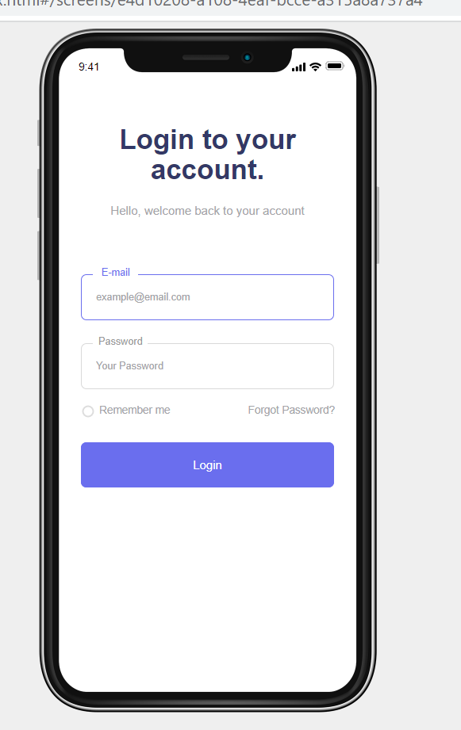

Create Account Screen:
A user can "Create Account" refers to the procedure of registering or signing up for a new account on an App in the Mobile, application, or online platform. It enables users to set up a personal or user-specific account that gives them access to system features, functionalities, or specialized experiences.
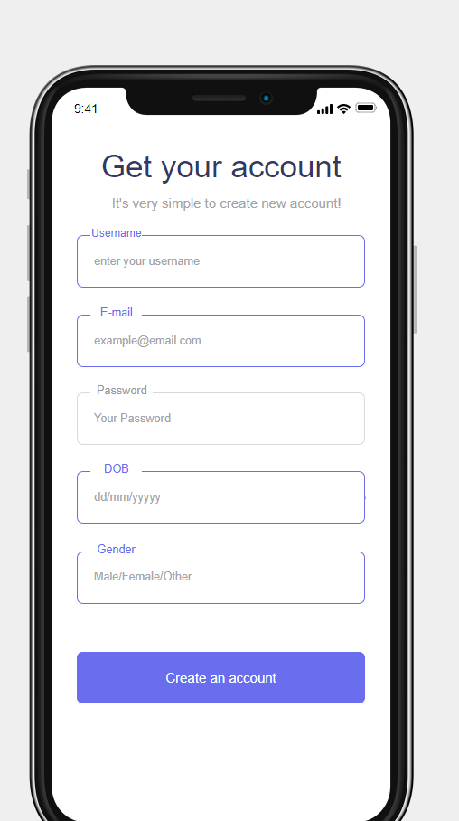

Cart Screen:
Users can gather and temporarily keep products they want to buy in this storage area.
Frequently, people will refer to it as a "shopping cart" or "shopping basket."
Users can add products to their carts as they browse an online store or website using the cart functionality, and then go to the checkout to finish their purchases.
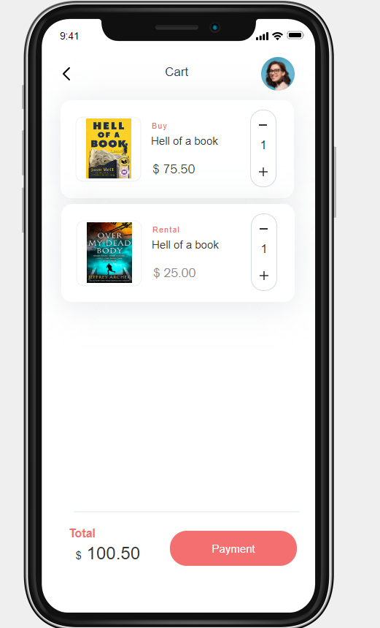

Home Screen:
The home screen's function is to give consumers a quick overview of the Bright Light platform's features, contents, and options. Typically, it acts as the main hub from which users can access the app's many components.
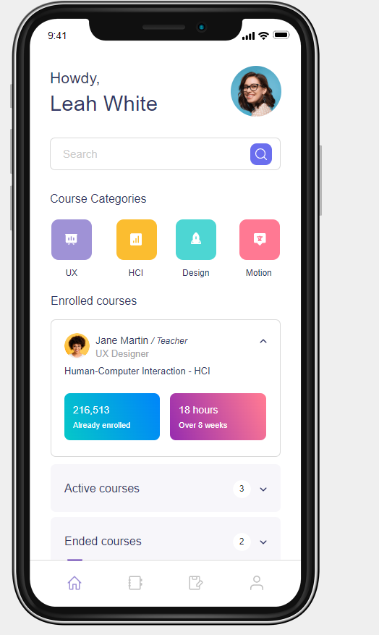

Books Screen:
Here User can see the all the books and search for books also.
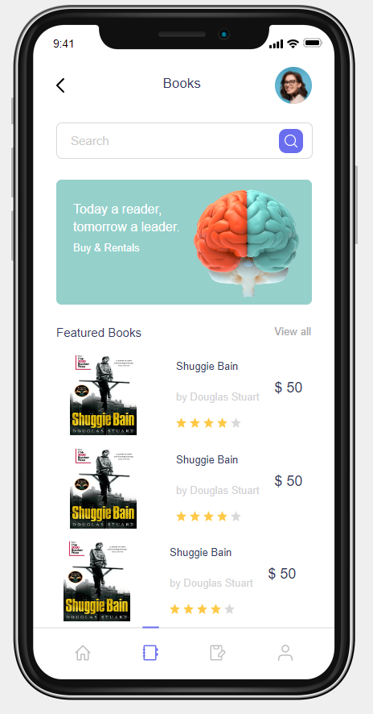

Notification Screen:
A notification screen, which is sometimes referred to as a notifications panel or a notifications center, is a screen or user interface component that shows notifications and alerts from multiple sources or apps inside of a system or device. To keep consumers informed of critical changes, messages, or events, it gives them a central spot to monitor and control notifications.
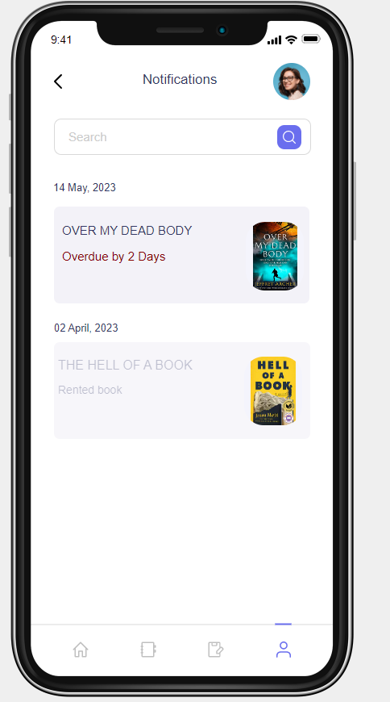

Search Screen:
Users can do searches within an application, website, or system using a search screen, which is also referred to as a search interface or search page. It offers customers a designated area to submit search queries and get pertinent results in accordance with their search requirements.
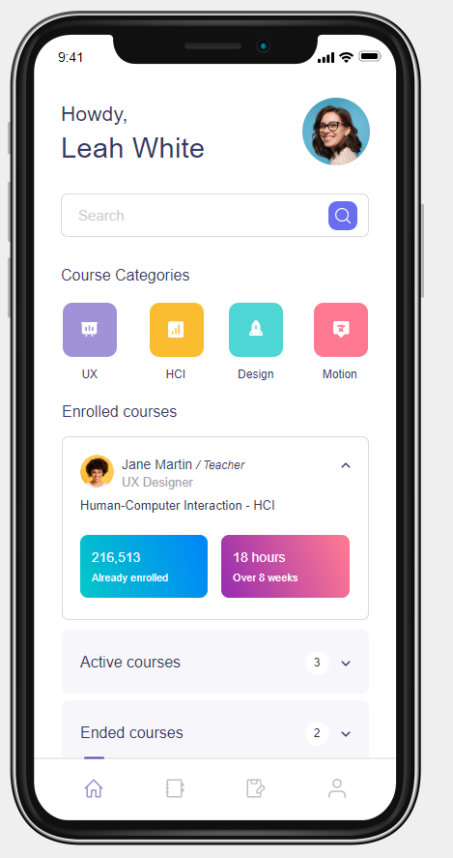

Book Details Screen:
A book details screen, often referred to as a book detail page or a book information page, is a user interface component or screen that offers in-depth details on a particular book within an application or website. It acts as a specific area where comprehensive facts and metadata on a specific book are shown, allowing users to discover more about the book's subject matter, author, publishing details, and other pertinent aspects.
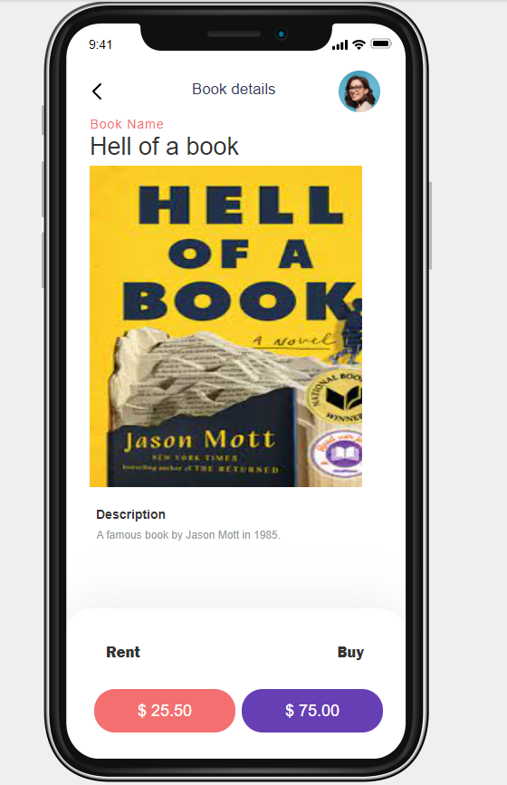

Profile Screen:

In android app profile screen, often called a user profile page or account settings page, is a user interface component or screen that shows and enables users to manage their personal profile information. It offers customers a specific area where they can examine and change the information about their accounts, preferences, and settings.
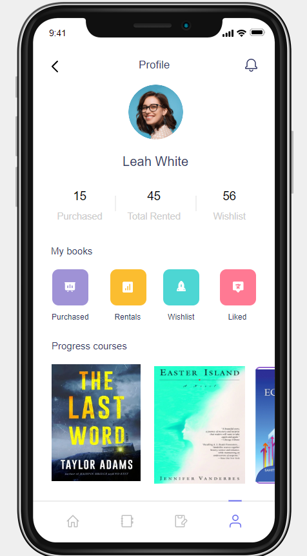

  - Use Case Diagrams
The interactions between actors (users or other systems) and the system itself are depicted visually in a use case diagram, which represents the functional requirements of a system. It shows how the system's many use cases and functionalities link to one another. Use case diagrams assist in illuminating system behavior as seen through the eyes of the user.

We have two actors in the example above: "User" and "Admin." Utilization scenarios are displayed for features like "Search Books," "View Details," "Add to Cart," "Checkout," "Manage Books," "Add Book," "Edit Book," and "Remove Book." From the viewpoint of the system's users, these are the main features of Bright Light Books.

Please take note that this is a condensed example, and that a use case diagram for the Bright Light Books project would probably include more actors, use cases, and relationships depending on the precise requirements and scope of the system.

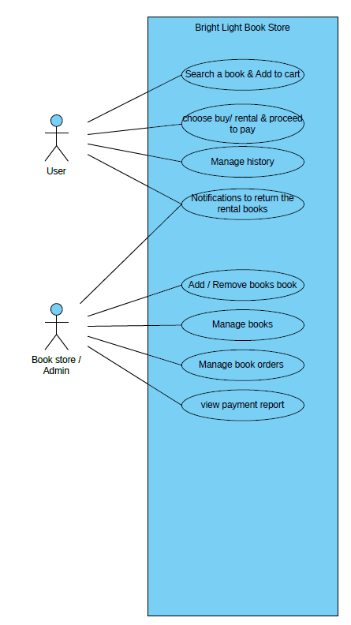

4.Design
4.1. ER diagram.
A visual depiction of a system's entities (things or concepts), their qualities,
and the relationships between them is called an ER (Entity-Relationship) diagram.
It is a well-known modeling tool used in relational database design to show how the data is structured and organized.
- Entities
- Attributes
- Relationships
- Primary Keys
We have two entities in the example above: "Book" and "Author." BookID, Title, ISBN, Publication Year, and Price are some of the traits that the "Book" entity possesses. Attributes like AuthorID, Name, and Nationality are present in the "Author" entity. As a result of the link "Writes" between the "Book" and "Author" entities, both an author and a book may have numerous authors.
ER-Diagram
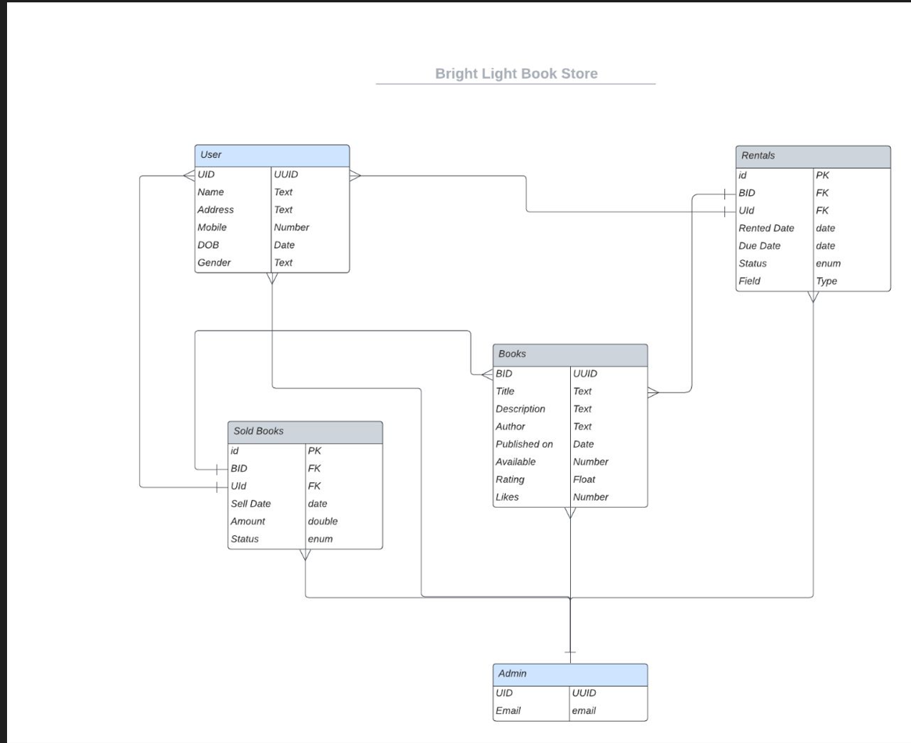
4.2. GUI
Graphical User Interface is what it stands for. It describes the visual user interface that allows people to engage with a computer system or software program. Users can interact with and explore a system more easily thanks to a GUI, which gives a visual representation of the system's features, functions, and controls.
Among a GUI's essential features are:
- Visual Elements
- Interactivity
- Feedback and Response
- Visual Layout
- Ease of Use
Home GUI
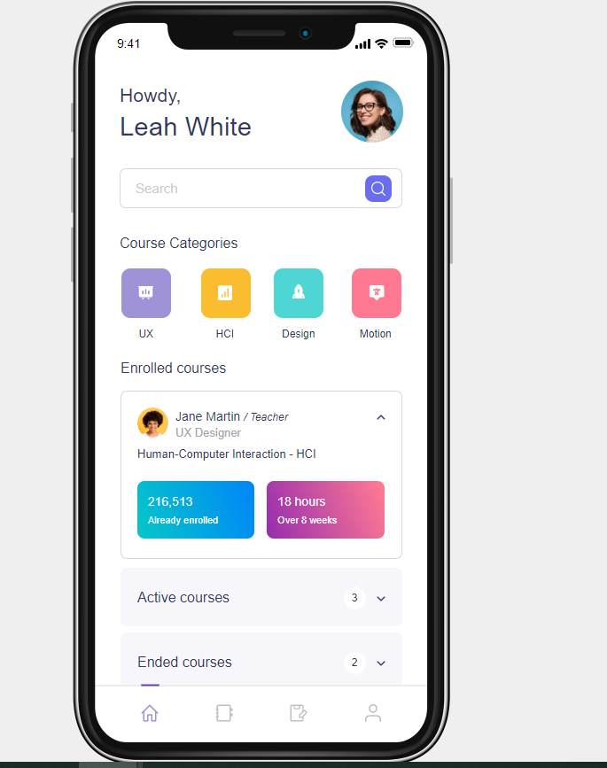

Book Screen:
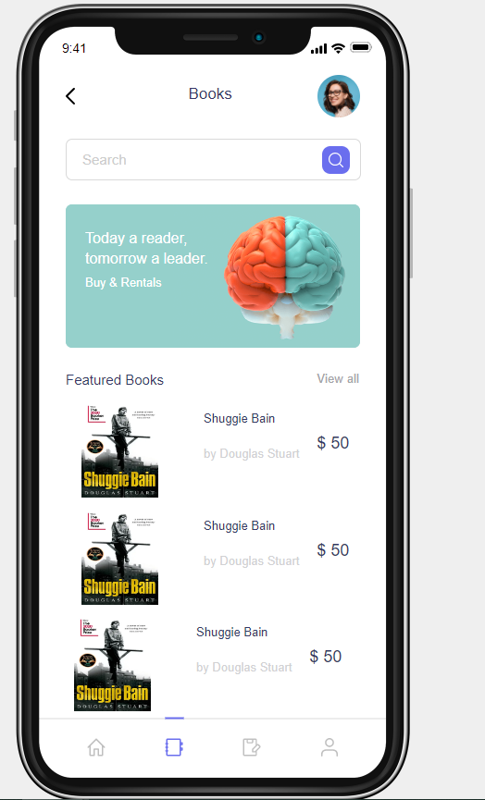

Login GUI:
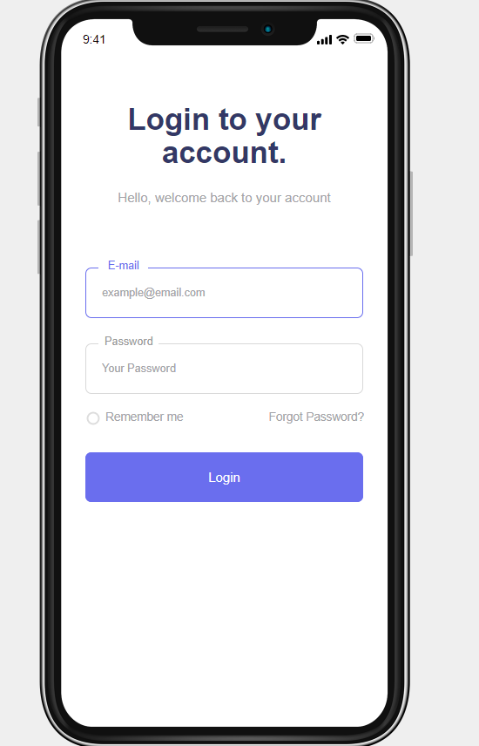

5.Analysis Models
5.1. Data Flow Diagram
A data flow diagram (DFD) shows how data moves through a system graphically. Since I lack precise information regarding the "bright light project," I'll give a broad illustration of a DFD for a lighting control system. This ought to give you some inspiration for the organization of your own DFD for the bright light project.
In this illustration, the "User Input" component refers to user interactions like switching on/off lights or modifying brightness settings. The "Control Module" analyzes the input from the user and produces control information. Following the transmission of this control information to the "Light Control Interface" component, which interacts with the "Light Control System" to regulate the lights appropriately.
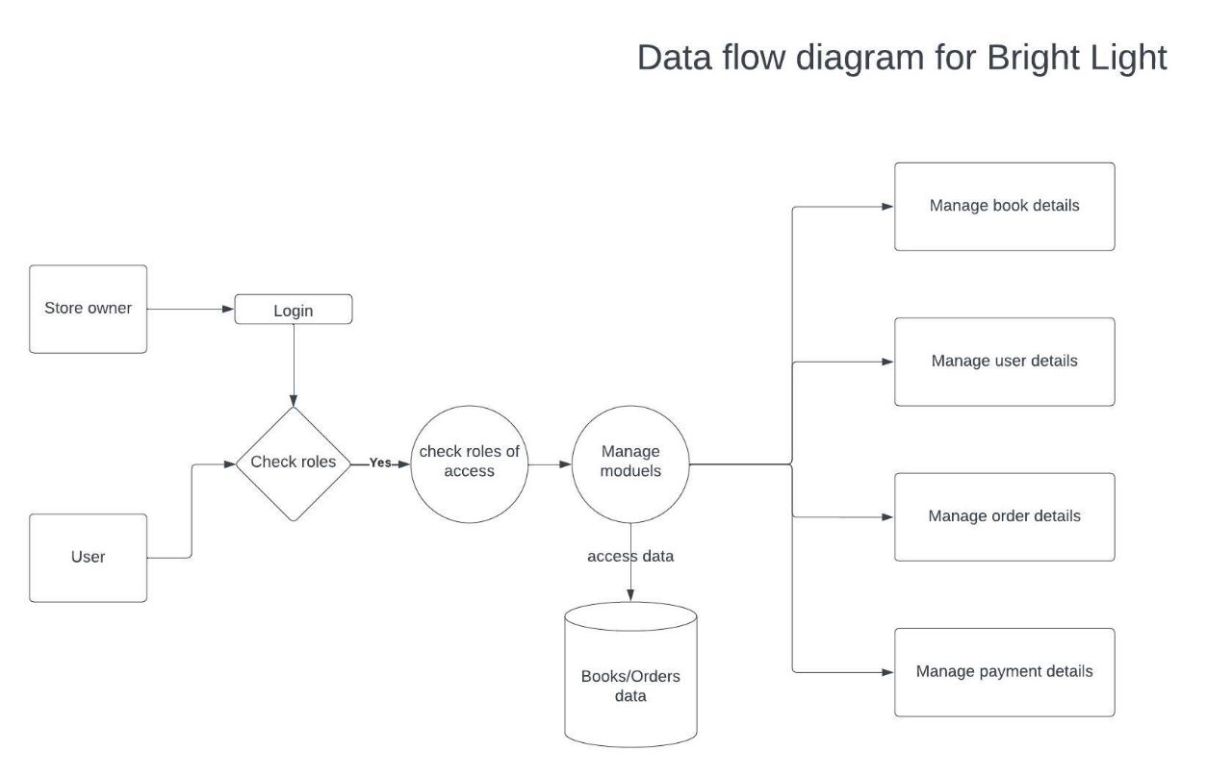

5.2. Sequence Diagram
Messages and interactions between various items or components in a system are shown using an interaction diagram called a sequence diagram. Here is an illustration of a sequence diagram for a fictitious "bright light project."
There are two key participants in this sequence diagram: "User Interface" and "Light Control." The user can modify the light's brightness via the user interface. The User Interface receives a status update from the Light Control component once it receives the brightness level, determines whether it is within acceptable bounds, and makes necessary light brightness adjustments.
Please be informed that this is a simplified example and that the actual Sequence Diagram for your "bright light project" may differ depending on the precise functionality and interactions involved.
